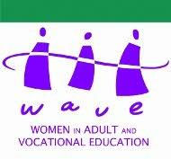

WAVE April Newsletter 2018
Welcome to WAVE networking, events and advocacy 2018. We would love you to join with us in promoting and supporting women and girls in VET and adult education.
WOW – Women of the World
WOW - Women of the World, is a global force supporting women and girls, action and change. Aimed at girls, boys, women and men, WOW celebrates women’s and girls' achievements and takes a frank look at the lives of women and girls and the obstacles that prevent them from reaching their full potential. More than one million participants have been involved to date, making WOW one of the biggest movements of women and girls in the world.
The festival was held in Brisbane during the Commonwealth Games. Go to: https://www.wowaustralia.com.au/ for more information.

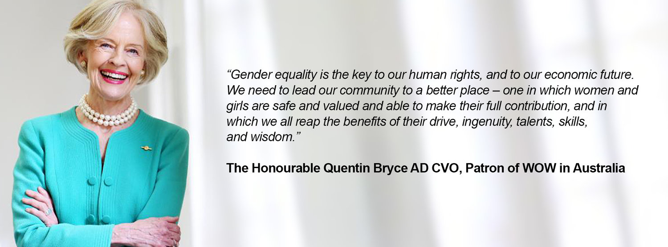

Australian Women’s Leadership Symposiums
The Australian Women's Leadership Symposiums are a national series of events focused on the experiences of women leaders in the contemporary workforce.

The Symposiums take place in every state and territory capital between May and August. Keynote speakers for 2018 include Gail Kelly, Professor Gillian Triggs, Nova Peris OAM OLY, Jessica Rowe AM, Ita Buttrose AO OBE, Katrina Webb OAM, The Right Hon Dame Jenny Shipley and many, many more.

The principal themes that will be tackled at this year’s events include:
- Resilience within the workplace
- Enabling women to lead
- The power of networking
- Being bold, being brave, being new
- Leading through change
- Getting comfortable with the uncomfortable.
An attendance discount of 25% is currently available by entering code ANSY18 at the time of booking (available until each Symposium sells out). For more information and to book: www.wla.edu.au/symposium

AVETRA VET Practitioners Research Conference
Come along to this conference in Melbourne on 26/27 April. To register: http://www.cvent.com/d/ytqf48
Cost: $25 AVETRA members or $225 non-members. A bargain, so join AVETRA today and then register for the conference.
Great program:
- International Guest Speaker – Jose Luis Fernandez Maure, from the Institute of Innovation and Applied Research for VET in the Basque country. As well as delivering the keynote address on Friday, he will conduct a workshop on Thursday on entrepreneurship and research capability development.
- A range of workshop sessions covering:
  - NCVER and its services, including how to work with NCVER in the future
  - Developing collaborative applied research proposals
  - Researching and understanding industry knowledge
  - Developing e-assessments for learning
  - Positives and negatives of insider research
  - Developing a small scale research project
will be held as well as presentations from VET practitioners.

2018 Australian Higher Education Women’s Leadership Summit scheduled for June 15th at the Intercontinental Sydney.
One day Summit with Key Note Speakers from leading educational institutes across Australian Education. The aim of the Summit is to contribute to the development of resolute and effective women leaders through skills development, expert advice and strategic industry based networking.
This year’s Summit Facilitator & Panel Moderator is Dr Janet Smith, Adjunct Associate Professor of Education, University of Canberra
Key Note Speakers include,
Professor Brian Schmidt V/C ANU
Professor Caroline McMillen V/C University of Newcastle
Professor Marcia Devlin Ass. Deputy VIC Education RMIT
Belinda Robinson CE Universities Australia
Dr Marguerite Evans-Galea Executive Director STEM
Professor Jill Blackmore Deakin University Professor of Education
Full event details and registration can be viewed via the following link.
https://www.wla.edu.au/highereducationsummit.html

MeToo is not enough says Eva Cox
A recent article by Eva Cox in the Conversation makes the following points: The evidence online and increasingly in reports and complaints, plus the intransigent domestic violence numbers, suggest current gender power imbalances are creating far too many damaging and unequal male-female relationships.
"#MeToo is not enough: it has yet to shift the power imbalances that would bring about gender equality" — http://theconversation.com/metoo-is-not-enough-it-has-yet-to-shift-the-power-imbalances-that-would-bring-about-gender-equality-92108=

Gender equality and education in the Sustainable Development Goals
This paper was prepared for UNESCO and is worth a read: unesdoc.unesco.org/images/0024/002455/245574e.pdf
It makes the following comment on education: Education is only one of the areas of social policy behind the breaking down of gender inequalities and the empowerment of women – progress in education alone is not sufficient for achieving gender equality either in or beyond education, and as this section has covered briefly, other factors such as the legal system, the labour market, welfare systems, culture and religion are crucial in determining the rights and freedoms available to women. Nonetheless, it is a fundamental building block for both individual capabilities, and collective changes in understandings and norms.
What is WAVE up to?
- WAVE wrote to the major parties in the lead-up to the Tasmanian and South Australian elections, asking for a commitment to:
* Ongoing provision for women and girls in all VET policies and programs, ensuring that these are high-quality, affordable, inclusive and relevant for the diversity of all Australian women
* Accessible education, training and retraining programs targeted specifically to women and girls
* Gender informed career advice and counselling for women and girls
* Technical and trade training for women and girls in areas of skill shortages, emergent occupations and industries, including male dominated occupations
* Increased training places targeting women out of low paid casualised jobs into viable, well-paid, tenured jobs
We also made the point that Australia has signed up to the UN Sustainable Development Goals (SDGs), and therefore all governments in Australia are obliged to meet these commitments to gender, education and decent work.
- WAVE sponsored some advertising on ICTV- Indigenous Community Television around International Women’s Day. Have a look at an example here. https://ictv.com.au/video/item/5333
What a great job they did in the Northern Territory.

- This year WAVE will again work with other women’s organisations in drafting the annual NFAW Gender Lens on the Budget. Any budgetary insights you might have in relation to gender and vocational and adult education, do let us know.

Keep up with WAVE campaigns through http://wave.org.au/wave/, Facebook, Twitter and LinkedIn.
Linda Simon WAVE National Convenor

